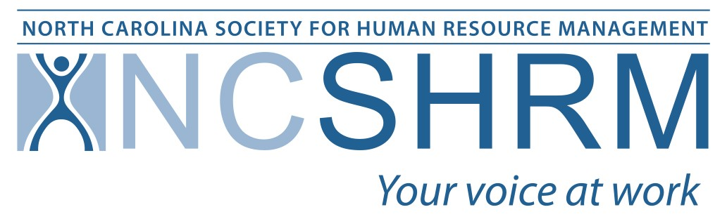  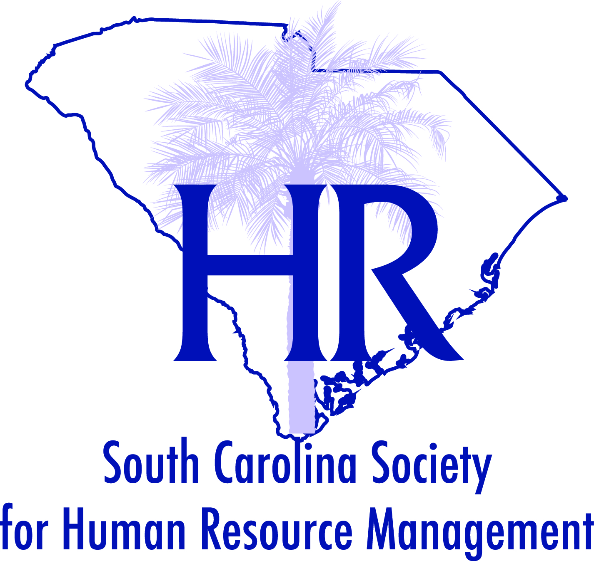  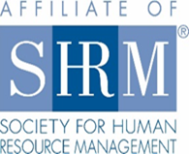  Carolina’s  HR Student Conference and Case Competition  When  February 28-29, 2020  Where  Anderson University. Anderson, SC  We Need You  The success of the State Student Case Competition is largely dependent on the financial assistance of our sponsors.  Your participation helps to facilitate student learning, growth, and networking.  We offer a variety of opportunities for your organization to get involved in supporting our HR students—the future of our profession! | Sponsorship Packages  Platinum Level $5,000  - Logo and weblink on conference website  - Logo on all press/promotional pieces  - Recognition in all general sessions  - 10 min of microphone time during the conference  - Sponsor ribbons for company attendees  - Opportunity to include company promotional items n conference bag  Gold Level $2,500  - Logo on conference website  - Recognition in all general sessions  - 5 min of microphone time during the conference  - Sponsorship ribbons for company attendees  - Opportunity to include company promotional items in conference bag  Silver Level $1,000  - Listing sponsor on conference website  - Sponsorship ribbons for company attendees  - Opportunity to include company promotional items in conference bag  Bronze Level $ 500  - Listing sponsor on conference website  - Sponsorship ribbons for company attendees  - Opportunity to include company promotional items in conference bag  In-Kind Items  - Conference Bags  - T-Shirts  - Padfolios  - Reception Sponsor  - Snack/Beverage Break Sponsors  - Items for conference bags  To become a sponsor or get more information please contact: jeffrey.luttrell@alorica.com  or call 919-368-3608.

